- The best way to control weaver birds is by scaring.
- Which of the following crop pests cuts young stems of seedlings? Stalk borers
- Climbers climb on other plants in search of air and sunlight
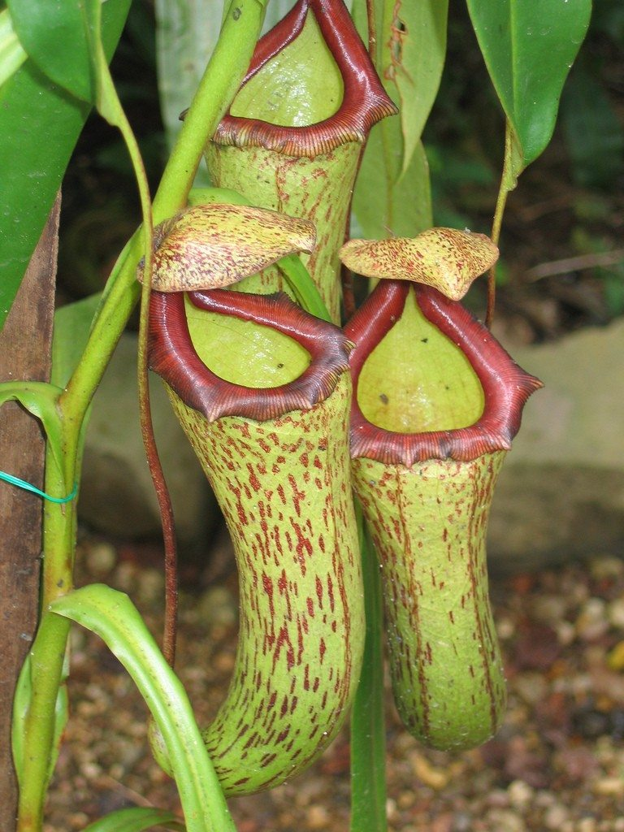
- Among the following plants, which one can be considered to be parasitic? Lichen

X

- What is the appropriate name of this plant? Pitcher plant
- The part marked X traps in order for the plant to get proteins.’
- Which of the following is an example of a plant that depends on other for shade? Fern
Grass antelopes
Lions Vultures
- According to the food chain above, vultures are tertiary consumers
- Which of the following statements would be true if all antelopes were suddenly killed by a disease? Grass would increase.
- In a food chain, which component should be plenty for the proper balance of nature? Carnivores.

Correction
2. Which of the following crop pests cuts young stems of seedlings? Cutworms
10. In a food chain, which component should be plenty for proper balance of nature? Green plants.

